

**Food Allergen Risk Assessment For Caterers**

People with food allergies have to take great care when eating out to avoid certain foods that could cause them harm. As a business you have a legal obligation to ensure that any food you produce or prepare is safe. There is, from December 2014, now a legal requirement to provide information to consumers about allergenic food sold unpackaged. You should be able to provide information on allergenic ingredients when asked. You may provide it by talking to your customers, as long as you have signs saying so, and that you have staff who can do this at all times.

**Main Food Allergens:**

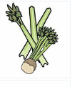    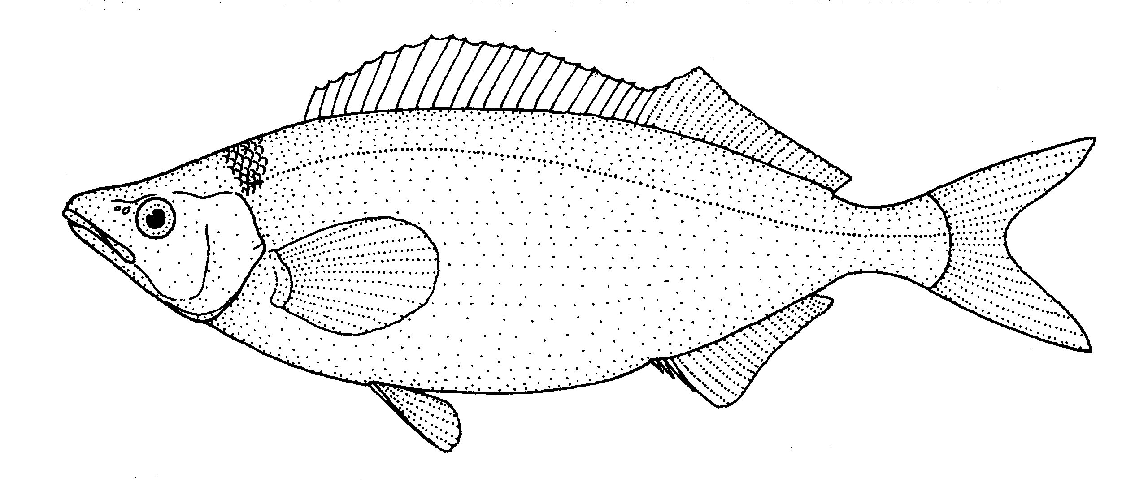  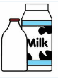

**Celery Cereals Crustaceans Eggs Fish Lupin Milk**

**Containing Gluten (Shellfish)**

 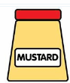     

**Molluscs Mustard Nuts Peanuts Sesame Seeds Soya Sulphur**

**(Shellfish) Dioxide**

The risk assessment has been divided into three sections covering Overall Management and Training, Kitchen Procedures and Front of House. This will allow you to assess whether the controls you currently have in place are effective and if any improvements can be made to ensure that the food you serve is safe.

If you are not certain that you can provide food that is suitable for someone with a food allergy, then you should tell them so. They can then decide whether or not to eat the foods you provide.

More guidance and outline training can be found on the Food Standards Agency at <https://www.food.gov.uk/business-training/guidancenotes/labelregsguidance/nonprepacked>

**Allergen Management and Training**

|  |  |
| --- | --- |
| **Question** | **Notes to Consider** |
| 1. Do you have a written policy on food   allergies and intolerances?    Yes No | You should consider the following:-   1. Read the Food Standards Agency Guidance (see   the link above).   1. Identify the allergen risks. 2. Decide who is to have overall management   responsibility for allergens and food safety. |
| 1. Are your First Aid Emergency procedures   up-to-date and rehearsed?  Yes No  (Please see guidance at end)  **Training**   1. Have all kitchen staff received food allergen   awareness training?  Yes No   1. Have front of house staff received food   allergen awareness training?  Yes No  It is good practice to ensure all training given to  staff is recorded and kept on file and that  refresher training is given on a regular basis.   1. Have your staff demonstrated to you that   they understand and can follow the  training?  Yes No | 1. Ensure training is given to all staff (both permanent   and temporary) and that there is always a trained  member of staff on duty during opening hours.   1. Plan how to minimise the risks. 2. Display notices to remind staff of the risks. 3. Plan how to communicate the risk between   members of staff, and to customers.  Training should include the following:-   1. Online training is available at   <https://www.food.gov.uk/business-industry/allergy-guide>   1. Staff should be warned of the effect of providing   the wrong information or serving food containing  an ingredient that a customer is allergic to.   1. Kitchen procedures to prevent cross-contamination   during storage, and preparation of food.   1. Identifying customers with food allergies when   they book a table, or when staff take orders  (e.g. menu reminders).   1. Consider providing a checklist or guidance that   staff can refer to whilst taking orders that  highlight which dishes contain which type of  allergenic ingredient.   1. A system for waiters to alert kitchen staff that the   food they are to prepare is for somebody who is  allergic to certain ingredients.   1. Dealing responsibly with a customer complaint   over concerns that their food may be contaminated  with an allergenic ingredient. Staff should not just  remove the ‘offending’ allergen from a prepared  dish and send it back on the same plate, because  traces of the allergen will remain which could  cause a reaction.   1. Ask your staff to explain what they must do when   a request for a meal without allergens is received. |

**Kitchen Procedures**

|  |  |
| --- | --- |
| **Allergenic Ingredient Identification**   1. Which allergens do you handle? – please tick √ (see diagram on page 1)   Celery  Cereals containing gluten (wheat, barley, rye, oats, spelt, kamut and their hybridised strains)  Crustaceans (eg. prawns)  Eggs  Fish  Lupin  Milk  Molluscs (eg. mussels)  Mustard  Nuts (eg. almonds, Brazil nuts, cashews,  hazelnuts, macadamias, pecans,  pistachios, Queensland nuts and walnuts)  Peanuts  Sesame Seeds  Soya and soya beans  Sulphur Dioxide and Sulphites (often expressed as SO2. Used as a preservative and often found in wine and dried fruit) | Prepare a list and how you will control their use, and prevent cross-contamination.  See separate grid you can use for ingredients and for menu dishes.  You must tell the customer the allergen present using the terms listed left  **You need to take steps to ensure this is carried out so you can comply with legislation to supply safe food.** |
| 1. Have you checked for allergens in ingredients you use? Including checking the labels of prepared food, sauces and seasoning mixes?   Yes No   1. Does your supplier provide you with adequate labelling information?   Yes No   1. Do you check to see if any substituted items that have been deliveries contain allergenic ingredients?   Yes No   1. Do you re-check for allergens if you have to change supplier?   Yes No | You should consider the following:-   1. If receiving food not pre-packed or without full labelling information: Contact your supplier for the information, and make sure they understand why you need the information. 2. Ensure they provide you with clear information and that they up-date you should the ingredients or their processing change. They are required by law to do this. 3. Think about how you can make staff remember to check for allergenic ingredients in new or replacement ingredients. For example, a delivery checklist. 4. All food should be labelled in English. If it is not, you should ask that your supplier provides ingredients details in English. You can then show customers what the food contains if needed. |
| 1. Do you record any of the above checks?   Yes No | You should consider how you would be able to demonstrate which steps you have taken to prepare safe food. For example:-   1. Written records. 2. How frequently are records made? 3. Who checks information is being recorded correctly?   See separate grid you can use for ingredients and for menu dishes. |
| **Storage**   1. Do you have a storage system to prevent cross-contamination of ingredients with all allergenic ingredients?   Yes No   1. If you transfer ingredients from packaging into storage containers or fridges/freezers, do you have a procedure for retaining product information such as date codes, batch codes, allergen information?   Yes No | You should consider the following:-   1. A colour code for allergenic ingredients. 2. A spillage plan to clean up allergenic ingredients. 3. How do you control transfer of ingredients and foods so that labelling is retained, so that all foods are clearly identified so that staff can check which allergens are in it? |
| **Preparation**   1. Do you follow any procedures when preparing food for a customer with a food allergy?   Yes No | You should consider the following:-   1. Check ingredient labelling for allergenic ingredients. 2. Consider dish preparation, separate equipment and utensils, storage, cooking/re-heating, separate preparation area. 3. Thorough cleaning before and afterwards. |
| Are the procedures clear to staff?   1. If yes, have you considered all aspects listed in the right hand column?   Yes No | Surfaces, containers, utensils, storage and preparation areas all must be regularly cleaned.   1. Adequate hand-washing. 2. If you re-use cooking oil, there is a probability that allergens such as nuts proteins/fish proteins/gluten will still be present. 3. Serving Procedures – for example, garnishes, topping a dessert with almonds, preventing cross-contamination when food is served in a buffet style. |
|  |  |
| **Front Of House** |  |
| 1. Do you inform customers about dishes that contain particular allergens, and ensure that information is available and clearly displayed?   Yes No  **Legally required from December 2014 to provide all allergen information on the menu**  **Or**  **Display a sign inviting customers to ask a member of staff. See the sign on page 6.**  Look out for these FSA chef cards    Customers may show you them  <https://www.food.gov.uk/multimedia/pdfs/chefcard.pdf> | The sign must be prominent and where customers make their choices, eg. at the bar, at waiting and eating areas, on all menus and blackboards.  You should:-   1. Ask your customers if they suffer from any food allergies and identify any dishes that they will not be able to eat. (Including for advance or group bookings and telephone orders). 2. Highlight on menu by including the allergenic ingredient in the name of the food description, if not obvious. 3. What about garnishes of nuts / breadcrumbs /croutons / sesame seeds etc? Are they stated on the menu? 4. Provide allergenic information on notices detailing the name of the food at serf-service counters, salad bars etc. Ensure foods containing no allergenic ingredients are sufficiently separated from food containing allergenic ingredients, and in a way to prevent any falling food contaminating it. Do you provide enough utensils to prevent cross-contamination? 5. Guide/Symbols to indicate which dishes contain certain allergenic ingredients are only allowed if full details are given. 6. Notices/details in menus (see suggested wording below). 7. Is any information available on your website? |
|  |  |
|  |  |
| **Phone and Internet Orders and**  **Home Delivery** |  |
| 1. On taking orders, do your staff ask if anyone has an allergy or intolerance to foods? 2. Do you use internet websites to advertise and take orders? How is the allergen information made available to customers making their food choices? Does the website clearly provide allergen information, or does it ask customers to say if thay have a food allergy or intolerance? 3. How do you ensure that the kitchen staff receive, understand and act on the request for meals without a particular allergen? 4. Are there any particular language and communication difficulties?   From the consumer?  Between staff? | Invite the discussion with your customers when they contact you.   1. Staff must know how to provide the information over the phone or on email/website orders. 2. Do the staff have access to a correct up-to-date list of allergen information? 3. Do your menus clearly show that customers should tell a member of staff if they have a food allergy or intolerance? What about the flyers and menus delivered to houses and given out to customers? 4. Do you use other businesses that take food orders on your behalf? How do they manage allergen information? 5. Buffets, food platters and outside catering – how do consumers get allergen information about the foods? How will you provide information that will be available to people about to choose and eat the food? 6. Allergen information will always need to be very clear because you will not know the allergen requirements for all those eating the food. 7. Prepared specific food in request for food without an allergen to be provided apart from other foods. |
| **Delivery**  When delivered, the food must be identified in writing with the allergen information.   1. Are meal containers clearly labelled to say which contain specific allergens? 2. You may, in addition, identify clearly which container has food made without a named allergen. | 1. The allergen information must be available to the customer at the moment of delivery of the food. 2. How do you ensure allergen labelling on home delivery containers? 3. Examples could include:-  * Stickers applied to each container when filled in the kitchen. Coloured stickers with the allergen name on it. * Pre-printed list on containers. * Handwritten in permanent ink – it must be readable. * A separate sign / menu / sheet of paper – but it must be possible to clearly identify which allergen information relates to which food product and it must not be confusing. |
| **Buffets and Platters Etc**   1. Are food displays clearly labelled? 2. How will you identify the allergens across the food display? | 1. Labels / signs must be clear and with the food at all times, whilst consumers are serving themselves. 2. Think how you group food platters etc – segregate by allergens? 3. Which controls help prevent cross-contamination?  * Separate serving utensils. * Segregation of particular foods depending on the allergen(s) present. * Layout of buffet food. For example, salads presented first, dressings containing allergens offered after. * Specific allergen-restricted foods identified, separated and protected. |
| It is suggested you display this poster in staff areas:  Copies in different languages and lots more resources are available from the Food Standards Agency website  [**https://www.food.gov.uk/business-industry/allergy-guide/allergen-resources**](https://www.food.gov.uk/business-industry/allergy-guide/allergen-resources)  For **online training** and more advice please see:  <https://food.gov.uk/business-industry/allergy-guide> |  |

**Information for Customers with Food Allergies**

**Benefits of Using the Signs Like the Ones Below**

* Use the words “Food Allergies and Intolerances” – so only customers who do have an allergy or intolerance need to read it.
* It invites the customer to share their problem – “we’ll help if we can, and if we can’t, we’ll say so”.
* It says to your customers:
* “We have a system in place – please ask and we’ll listen to you too”.
* “We are quite entitled to use these things in our products and only use them when appropriate, but also recognise that for some people they are very dangerous. So we will take care”.
* Having the notices raises awareness amongst the general public, and particularly acts as a reminder to all staff – including new or temporary.
* It can be very useful to change these notices regularly. Using different colours and images helps to keep staff and customers alert to the problem.

**Display on your premises everywhere that your customers choose food and drink and include on your menus:**

**✂…………..✂…………....✂……………...✂………..……✂………..….✂……….…..✂…………..✂..**

|  |
| --- |
| **FOOD ALLERGIES AND**  **INTOLERANCES**  **Before you order your food and drink**  **please speak to a member of staff**  **if you have a food allergy or intolerance** |

**Display this in your staff areas in a prominent position:**

|  |
| --- |
| Emergency Action  If an allergic customer becomes ill, it is likely that person – or someone with them – will  Say that he / she is suffering an allergic reaction.  They may use the word  “ANAPHYLAXIS”  **This is what to do:-**  Immediately send someone to dial 999, giving the following information:  **“THIS IS AN EMERGENCY. A CUSTOMER HAS COLLAPSED AND WE BELIEVE THEY ARE SUFFERING FROM ANAPHYLAXIS.” (Pronounced ANA-FILL-AXIS)**  **ASK FOR AN AMBULANCE WITH A PARAMEDIC**  **SPEAK CLEARLY SO THAT THE AMBULANCE CREW WILL KNOW EXACTLY WHERE TO COME**  **(TELL THEM THE POSTCODE IF YOU KNOW IT)**   * Someone should stand at the entrance to direct the ambulance crew to the patient. * **Any staff trained in First Aid should learn what to do if someone has an Anaphylactic reaction.** * Ask other customers if there is a Doctor in the Restaurant.   **Remember, death can take place within 10 minutes.**  **Prompt and immediate action is vital.** |

|  |
| --- |
| FOOD ALLERGIES  And  INTOLERANCES  **Please speak to our staff about the ingredients**  **in your meal, when making your order.**  **Thank You** |